SQL Coding Challenge Submission

**E-Commerce Relational Database Management System (RDBMS)**

# Name: Gaurav Singh

# Superset ID: 5277273

# Email: 2116181@saec.ac.in

# Submitted To:

# Hexavarsity Training Program,

# Hexaware Technologies

# Schema and Data Insertion:

# Create Tables:

1. -- Customers Table
2. CREATE TABLE customers (
3. customer_id INT PRIMARY KEY,
4. name VARCHAR(100),
5. email VARCHAR(100),
6. password VARCHAR(100)
7. );
8. -- Products Table
9. CREATE TABLE products (
10. product_id INT PRIMARY KEY,
11. name VARCHAR(100),
12. description TEXT,
13. price DECIMAL(10, 2),
14. stockQuantity INT
15. );
16. -- Cart Table
17. CREATE TABLE cart (
18. cart_id INT PRIMARY KEY,
19. customer_id INT,
20. product_id INT,
21. quantity INT,
22. FOREIGN KEY (customer_id) REFERENCES customers(customer_id),
23. FOREIGN KEY (product_id) REFERENCES products(product_id)
24. );
25. -- Orders Table
26. CREATE TABLE orders (
27. order_id INT PRIMARY KEY,
28. customer_id INT,
29. order_date DATE,
30. totalAmount DECIMAL(10, 2),
31. shipping_address VARCHAR(255),
32. FOREIGN KEY (customer_id) REFERENCES customers(customer_id)
33. );
34. -- Order Items Table
35. CREATE TABLE order_items (
36. order_item_id INT PRIMARY KEY,
37. order_id INT,
38. product_id INT,
39. quantity INT,
40. itemAmount DECIMAL(10, 2),
41. FOREIGN KEY (order_id) REFERENCES orders(order_id),
42. FOREIGN KEY (product_id) REFERENCES products(product_id)
43. );

# Data Insertion:

1. INSERT INTO products (product_id, name, description, price, stockQuantity) VALUES
2. (1, 'Laptop', 'High-performance laptop', 800.00, 10),
3. (2, 'Smartphone', 'Latest smartphone', 600.00, 15),
4. (3, 'Tablet', 'Portable tablet', 300.00, 20),
5. (4, 'Headphones', 'Noise-canceling', 150.00, 30),
6. (5, 'TV', '4K Smart TV', 900.00, 5),
7. (6, 'Coffee Maker', 'Automatic coffee maker', 50.00, 25),
8. (7, 'Refrigerator', 'Energy-efficient', 700.00, 10),
9. (8, 'Microwave Oven', 'Countertop microwave', 80.00, 15),
10. (9, 'Blender', 'High-speed blender', 70.00, 20),
11. (10, 'Vacuum Cleaner', 'Bagless vacuum cleaner', 120.00, 10);
12. INSERT INTO customers (customer_id, name, email, password) VALUES
13. (1, 'John Doe', 'johndoe@example.com', 'password1'),
14. (2, 'Jane Smith', 'janesmith@example.com', 'password2'),
15. (3, 'Robert Johnson', 'robert@example.com', 'password3'),
16. (4, 'Sarah Brown', 'sarah@example.com', 'password4'),
17. (5, 'David Lee', 'david@example.com', 'password5'),
18. (6, 'Laura Hall', 'laura@example.com', 'password6'),
19. (7, 'Michael Davis', 'michael@example.com', 'password7'),
20. (8, 'Emma Wilson', 'emma@example.com', 'password8'),
21. (9, 'William Taylor', 'william@example.com', 'password9'),
22. (10, 'Olivia Adams', 'olivia@example.com', 'password10');
23. INSERT INTO cart (cart_id, customer_id, product_id, quantity) VALUES
24. (1, 1, 1, 2),
25. (2, 1, 3, 1),
26. (3, 2, 2, 3),
27. (4, 3, 4, 4),
28. (5, 3, 5, 2),
29. (6, 4, 6, 1),
30. (7, 5, 1, 1),
31. (8, 6, 10, 2),
32. (9, 6, 9, 3),
33. (10, 7, 7, 2);
34. INSERT INTO orders (order_id, customer_id, order_date, totalAmount, shipping_address) VALUES
35. (1, 1, '2023-01-05', 1200.00, '123 Main St, City'),
36. (2, 2, '2023-02-10', 900.00, '456 Elm St, Town'),
37. (3, 3, '2023-03-15', 300.00, '789 Oak St, Village'),
38. (4, 4, '2023-04-20', 150.00, '101 Pine St, Suburb'),
39. (5, 5, '2023-05-25', 1800.00, '234 Cedar St, District'),
40. (6, 6, '2023-06-30', 400.00, '567 Birch St, County'),
41. (7, 7, '2023-07-05', 700.00, '890 Maple St, State'),
42. (8, 8, '2023-08-10', 160.00, '321 Redwood St, Country'),
43. (9, 9, '2023-09-15', 140.00, '432 Spruce St, Province'),
44. (10, 10, '2023-10-20', 1400.00, '765 Fir St, Territory');
45. INSERT INTO order_items (order_item_id, order_id, product_id, quantity, itemAmount) VALUES
46. (1, 1, 1, 2, 1600.00),
47. (2, 1, 3, 1, 300.00),
48. (3, 2, 2, 3, 1800.00),
49. (4, 3, 5, 2, 1800.00),
50. (5, 4, 4, 4, 600.00),
51. (6, 4, 6, 1, 50.00),
52. (7, 5, 1, 1, 800.00),
53. (8, 5, 2, 2, 1200.00),
54. (9, 6, 10, 2, 240.00),
55. (10, 6, 9, 3, 210.00);

# Database Table Output:

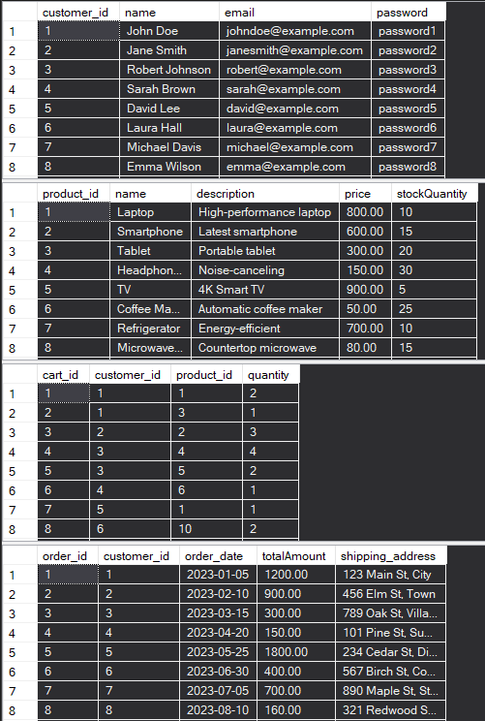

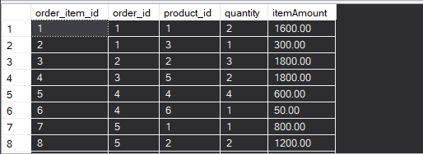

# SQL Tasks and Solutions:

## 1. Update refrigerator product price to 800

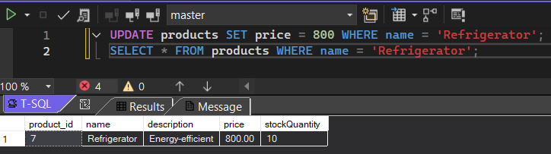

## 2. Remove all cart items for a specific customer (e.g., customerID = 3)

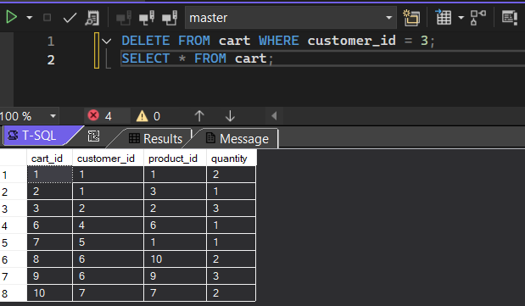

## 3. Retrieve Products Priced Below $100

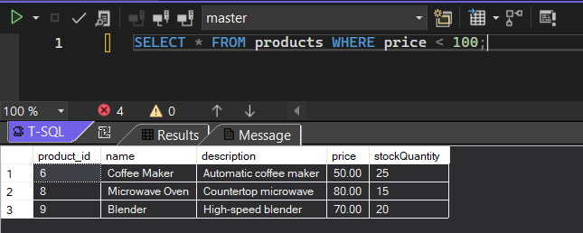

## 4. Find Products with Stock Quantity Greater Than 5

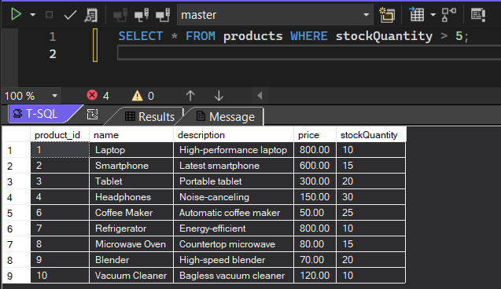

## 5. Retrieve Orders with Total Amount Between $500 and $1000

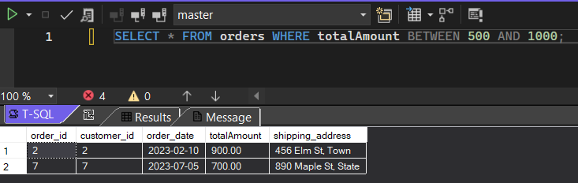

## 6. Find Products which name end with letter ‘r’

## 

## 7. Retrieve Cart Items for Customer 5

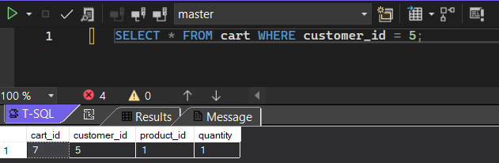

## 8. Find Customers Who Placed Orders in 2023

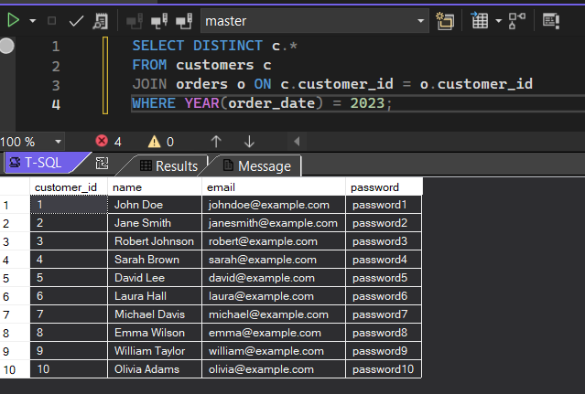

## 9. Determine the Minimum Stock Quantity for Each Product

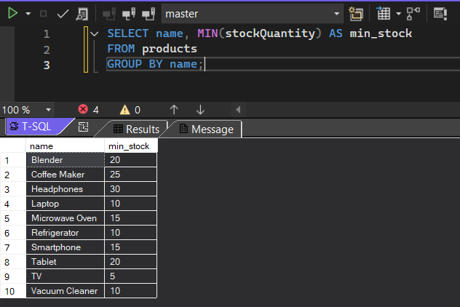

## 10. Calculate the Total Amount Spent by Each Customer

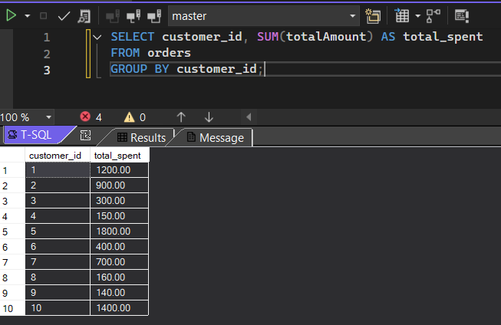

## 11. Find the Average Order Amount for Each Customer

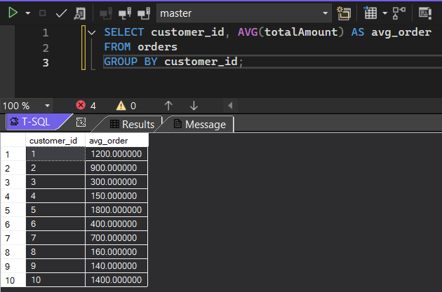

## 12. Count the Number of Orders Placed by Each Customer

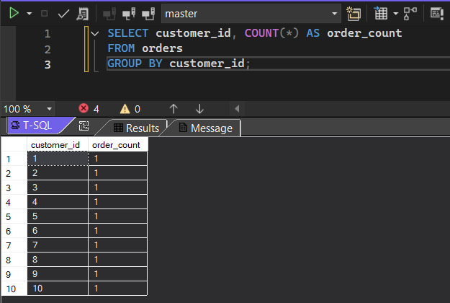

## 13. Find the Maximum Order Amount for Each Customer

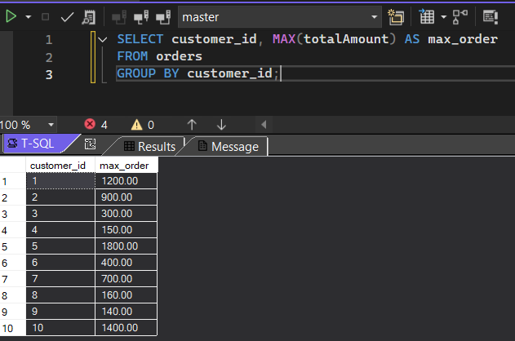

## 14. Get Customers Who Placed Orders Totaling Over $1000

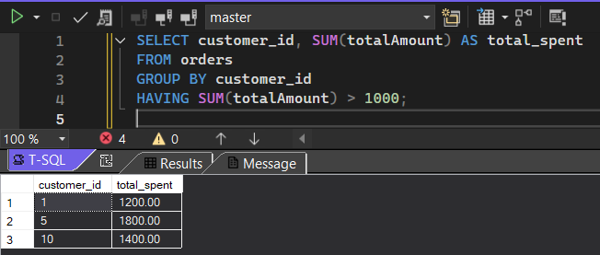

## 15. Subquery to Find Products Not in the Cart

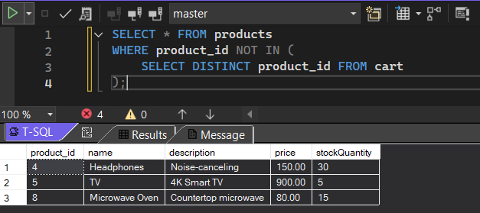

## 16. Subquery to Find Customers Who Haven't Placed Orders

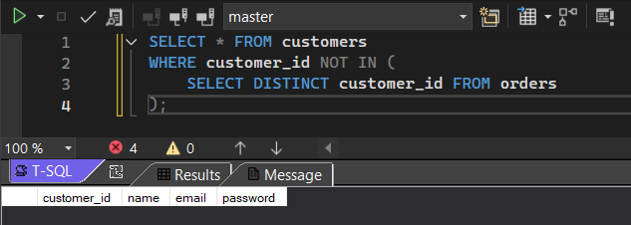

## 17. Subquery to Calculate the Percentage of Total Revenue for a Product

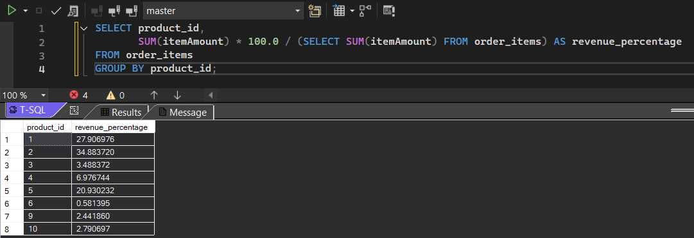

## 18. Subquery to Find Products with Low Stock

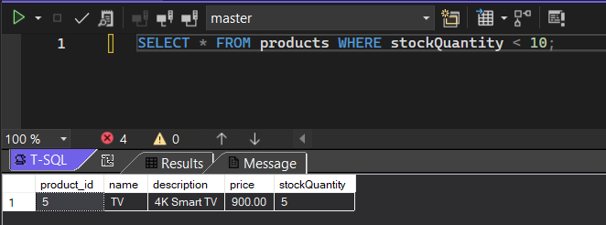

## 19. Subquery to Find Customers Who Placed High-Value Orders

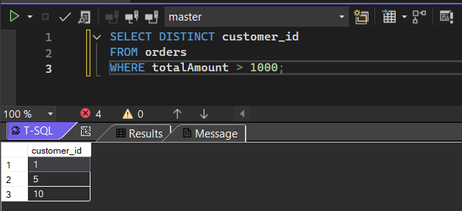

# Final Notes:

I’ve completed all 19 SQL tasks using the sample e-commerce data. This exercise helped me practice different types of queries like:

* Updating and deleting data
* Using joins and subqueries
* Filtering with conditions
* Grouping and aggregation

I tested everything in my local environment using SQL Server (Visual Studio), and checked the output for each query. It was a good refresher on real-world SQL operations, especially for things like finding customer behaviour and product trends.

Thanks for the challenge!

**Submitted by:** *Gaurav Singh*  
**Email:** *2116181@saec.ac.in*  
**Superset ID:** **5277273**